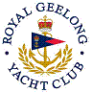 | Royal Geelong Yacht Club Inc.  Est 1859
Not a Trophy Deed of Gift.

Trophy: | Lofty (Syd) Thomas Recognition Award
Presented by:
Date: | 2005
For: | Person / Organisation Deemed most worthy
Remarks / Revisions
Click HERE for a list of Recipients

